**Leader Overview**

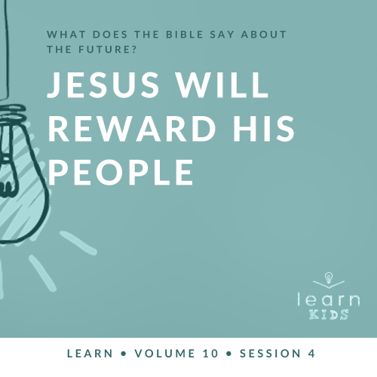

**Volume Overview**

**What does the Bible say about the future?**

*It’s easy to see that our society is obsessed with the future. But what does the Bible say about the future? While it was written thousands of years ago and much of its contents has already taken place, we do get a glimpse of the future in the Bible. We know there is life beyond this life. We know the brokenness and pain in this world will not last forever. We know God will make all things new, and He will right every wrong. For Christians, the future is something we can look forward to.*

**Session Overview**

**Jesus Will Reward His People**

*In the end, Jesus will sit on His throne and judge all people based on their life on earth. Those who chose to follow and obey Him will be received, and those who refused will be rejected. Jesus used the Parable of the Sheep and Goats to alert people to this upcoming judgment. He wants to reward those who live a life that is faithful to Him. If we choose not to live for Him, we won’t get a second chance to change our mind.*

**Bible Lesson**

Parable of the Sheep and Goats

[Matthew 25:31–46](https://ref.ly/logosref/Bible.Mt25.31-46)

**Faith Fact**

Jesus rewards His people.

**Faith Verse**

[1 Corinthians 2:9](https://ref.ly/logosref/Bible.1Co2.9) (NLT)

“No eye has seen, no ear has heard, and no mind has imagined what God has prepared for those who love him.”

**Preparing for the Session**

**Leader Preparation Time: 20–25 Minutes**

|  |
| --- |
| ***You Will Need***  ***Large Group***   * *Bible* * *Worship songs (Song suggestions: “Revelation Song” by Gateway Worship; “Ready or Not” by Hillsong UNITED; “Alive” by Hillsong Young & Free; “Zeal” Lyric Video by The Belonging Co)* * *For groups not using a phone or tablet only, add:*   *• Projector or TV*  *• Laptop*  *•* ***Faith Fact Slide***  *•* ***Faith Verse Video*** *or* ***Slide***  *•* ***Bible Lesson Video***  *•* ***Teaching Point Slides 1–3***   * *Prizes*   ***Small Group***   * ***Small Group Group Connection Page****, one per group* * *Scissors* * *Cup or envelope, one per group* * *Small prizes or candy* * *Bibles for kids in your group to share* * *Small prize* * *Soft ball* * ***Small Group Activity Page****, one per kid*   *To access session content and videos from a computer, visit:* [*BibleEngagementProject.com/downloads*](https://bibleengagementproject.com/downloads) |
| ***Getting Ready***  ***Large Group***   * *Download videos and slides if needed.* * *Select worship song(s) and have them ready to play.* * *Read the Bible Lesson Scripture to prepare for teaching time.*   ***Small Group***   * *Print and cut apart the* ***Small Group Group Connection Page****, one per group. Place slips in the cup or envelope.* * *Print copies of the* ***Small Group Activity Page****, one per kid.*   *First time leading* Learn *for Kids? Check out the* [*Facilitator Guide*](https://0b769b0ed3569ef9d18b-f88d8272f61086866d50d048b43ef630.ssl.cf2.rackcdn.com/sites/biblengagementproject/Listen_Facilitator_Guide.pdf)*.* |

**Large Group**

**30 Minutes**

*See what’s needed at the beginning of the session.*

**Introduction**

I’m so glad you’re here today! Let’s keep looking at what the Bible has to say about the future. Last time we learned about the judgment that will happen for all of us at the end of our life. Jesus gives us all the choice to follow Him or not. And when we’re following Jesus, every day we get to choose to live for Him the best we can. God’s Word tells us we’ll answer for our choices at the end.

The good news is that the Bible also talks about Jesus rewarding His people in the end if they choose to follow Him and stay faithful. Who loves getting rewards? *(Group response)* I think everyone does!

**Faith Fact**

Our Faith Fact tells us what Christians can look forward to. Our Faith Fact today is **Jesus rewards His people.**

• *Show the* ***Faith Fact Slide.***



Say the Faith Fact with me. **Jesus rewards His people.** Let’s say it one more time, but this time, let’s pretend rewards are raining down from heaven. Try to catch them all and say the Faith Fact! **Jesus rewards His people.** I don’t know about you, but I don’t want to miss out on the reward Jesus has for me.

**Game**

**Watch Out for Goats!**

In today’s parable, Jesus calls some people *sheep* and other people *goats*. Which animal would you rather be? Shout it out. *(Group response)* After we read the Bible story, we’ll see if you want to change your answer.

In this game, there will be one or more goats who are It. No one will know who the goats are. The goats’ job is to tag everyone, so you’ll have to watch out for them and try not to get tagged. If a goat tags you, you’re out. Watch closely and try to figure out who the goats are!

• *Have all the kids close their eyes.*

• *Tap two or more kids on the shoulder to select them to be the goats.*

Everyone, open your eyes! As we play, the goats will sneak around and tag sheep by tapping you on the shoulder. When a goat tags you, go and sit down. Let’s play!

• *Adjust the number of goats as needed.*

• *Play again if you have time.*

That was a tough game, because you didn’t know who the goats were at first. But some of you paid close attention and figured it out quickly. One day, Jesus will decide which people are the sheep and which people are the goats. We’ll find out more about that in our Bible story. But first, let’s worship together.

**Worship**

Let’s thank Jesus for loving us and wanting us to follow Him. He is already preparing amazing rewards for us in the future. We can praise Him by singing these songs together.

• *Lead the kids in singing one or two praise songs. See suggestions at the beginning of the session.*

**Bible Lesson**

Jesus often taught people using parables. He knew people would understand His teaching better if He told stories they could relate to. Today we’ll learn from a parable Jesus used to teach people about the future. Jesus wanted us to know how important it is to choose to live for Him before it’s too late. The parable we learned last time showed us that Jesus will judge everyone someday. Today’s parable tells us more about that. Judgment doesn’t sound like fun, but Christians don’t have to be afraid of it. After all, we’re following Jesus! Let’s pray and ask Jesus to show us how we can stay faithful to Him.

**Prayer**

|  |
| --- |
| *Dear Jesus, please help us stay faithful to You and love others the way You love us. Amen.* |

**Video Intro**

Before we look at the Bible story, let’s watch this video.

• *Play* ***Bible Lesson Video.***

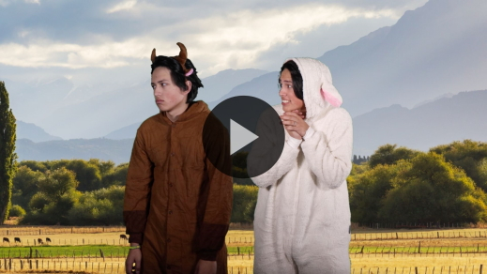

**Bible Story**

**Parable of the Sheep and Goats**

That video was a great lead-in to our Bible story! In today’s parable, Jesus compared people to goats and sheep. Remember, Jesus is called the Good Shepherd many times in the Bible. Remind me. Which animal do you want to be again? A sheep or a goat? Shout it out. *(Group response)* We’ll have to read the Bible story to find out if you picked the right one. It’s time to open your Bible or Bible app and go to [Matthew 25:31–46](https://ref.ly/logosref/Bible.Mt25.31-46).

• *Read the passage aloud to the group.*

• *In order to keep Large Group time moving along, we don’t recommend having the kids read.*

• *Optional: Remind the kids to mark this place with their Bible Bookmark, so they can read it on their own at home.*

**Teaching Time**

|  |
| --- |
| ***You Will Need***   * *Prizes*   *No prep needed for this activity.* |

So *sheep* or *goat*—did you choose the right one? *(Group response)* Jesus’ parable reminds us how much it matters that we’re faithful to Him our whole life. We don’t want to be the goats in His story. We want to be faithful sheep who follow our Shepherd and listen to His voice. As we listen to Jesus and obey everything He says, there are wonderful rewards. Remember our Faith Fact? Say it with me. **Jesus rewards His people.**

It can be hard to follow Jesus and stay faithful to Him, especially when people around us are going a different way. But we shouldn’t get distracted by the “goats” who try to turn us away from Jesus. Instead, we need to keep our focus on Him and follow Him faithfully. If we do that, He promises to bless and reward us. This parable shows us we should live with the future in mind.

**1. Jesus will judge our faithfulness to Him.**

• *Show the* ***Teaching Point 1 Slide.***

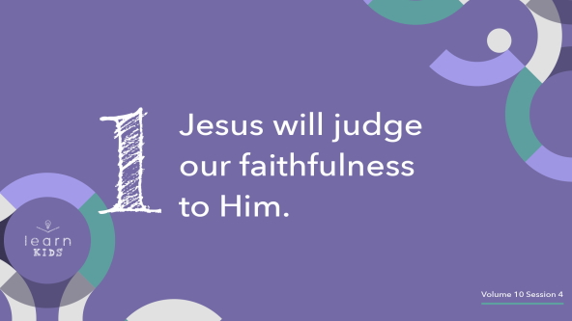

In the end, Jesus will judge every person based on whether they were faithful or unfaithful to Him during their life. What do you think it means to be faithful to Jesus? *(Allow responses.)* Those were some great answers. I think a real-life example will help us understand even better.

How many of you have friends? Raise your hand. *(Group response)* What about a best friend? *(Group response)* When someone is your friend, especially your best friend, you should be able to trust that person with anything. You trust them with your favorite toy. You trust them with your secrets. You trust that they will stand with you no matter what.

But what happens if a friend breaks your trust? What if they lose your toy and don’t say sorry? What if they tell other people your secrets? What if they talk about you behind your back? Would you trust that friend anymore? *(Group response)* Would you consider them to be a faithful friend? Or an unfaithful friend? *(Group response)*

Jesus expects us to be His faithful friends. That means we follow Him, spend time with Him, and choose to do the right thing no matter what. We will all be judged by Jesus one day. So let’s be judged as His faithful friends when the time comes.

**2. Jesus will reward those who follow Him faithfully.**

• *Show the* ***Teaching Point 2 Slide.***

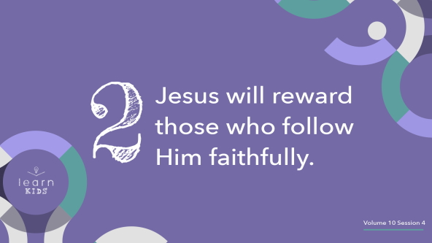

Who loves prizes? *(Group response)*

• *Begin tossing prizes at random to get kids excited.*

We all love prizes, but *rewards* are even better. Why? Because a reward means you did something special to earn it. Jesus will reward Christians who chose to stay faithful to Him. If we’ve stayed committed to Jesus, we will be rewarded by Him. We’ll get to spend forever with Him in heaven.

But it’s important to remember we’re not earning our way into heaven by doing good things. This isn’t like a rewards system where if we get enough gold stars, then we get into heaven. In fact, there’s nothing we could ever do to earn our way into heaven. Jesus is the only way to get to heaven. Jesus chose to come to earth and die for us. When He died on the Cross and rose again, He paid for our sins so we could go to heaven.

When we choose to believe in and follow Jesus, it’s like we’re a brand-new person. We start a new life of following Jesus and staying faithful to Him. It’s a life full of doing the good things Jesus wants us to. In today’s parable, He listed some examples of the kinds of things we should do. For example, we should treat others with kindness because Jesus has been kind to us. That’s the kind of life He wants to reward!

**3. Jesus will punish those who reject Him.**

• *Show the* ***Teaching Point 3 Slide.***

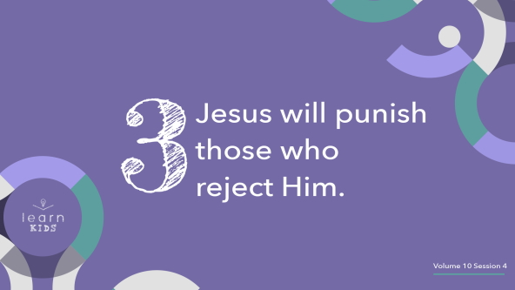

Who loves punishment? Raise your hand. *(Group response)* I might have tricked a few of you, but most of you were listening. A few minutes ago, you were so excited to get prizes! But no one wants to get a punishment. It’s never fun to be punished, but a lot of times, it’s deserved. It’s really sad, but there will be people who choose not to follow Jesus. They are like the goats in the parable we just read. They want to choose to do their own thing, so they choose not to become a Christian. Some don’t even believe in God.

We don’t love talking about it, because it’s so sad. But there will be punishments for people who choose to sin instead of following Jesus. The punishments for sin last forever. And when a person dies, their choice can’t be changed.

We talked about this a little last time. It’s important enough to say again. If we choose not to follow Jesus and don’t stay faithful to Him, we won’t get a do-over or second chance. Jesus doesn’t want to punish any of us, and that’s why He gave us a choice. If we decide to reject Jesus—which means saying no to Him—He will have to reject us when He judges us in the end. That means He will say no to us living in heaven with Him forever. So who will you be? The sheep who follows the Good Shepherd faithfully? Or the goat who goes their own way?

**Prayer and Response**

*Consider playing a worship song softly in the background while kids pray.*

Jesus wants us to be His sheep, and He wants to be our Good Shepherd. To follow the Shepherd, sheep need to hear His voice. Did you know we can learn to listen to His voice and follow Him faithfully? The first step in hearing His voice is to sit quietly and listen. We’re going to take some time to practice quietly listening for our Shepherd’s voice.

• *Spend a couple of minutes in silent prayer.*

• *Encourage kids to be quiet and respectful during this time.*

Maybe you feel like Jesus spoke to you today. And maybe you don’t. That’s okay. I want to encourage each of you to take some time every day to stop and listen for Jesus to speak to you.

**Prayer**

• *Optional: Have the kids repeat phrases of the prayer after you.*

|  |
| --- |
| Dear Jesus, help me take the time to listen to Your voice and follow what You say. Help me do the kinds of things You want to reward. I want to stay faithful to You my whole life. I want to spend forever in heaven with You. Amen. |

**Faith Verse**

Our Faith Verse reminds us we have a great reward to look forward to after our life ends. If we’re Christians and have faithfully followed Jesus, God is preparing something amazing for us! Let’s say our Faith Verse and do the actions together.

• *Play* ***Faith Verse Video.***

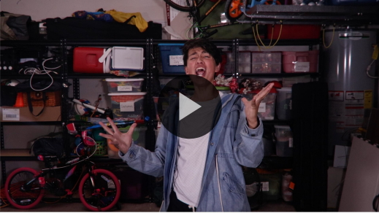

[1 Corinthians 2:9](https://ref.ly/logosref/Bible.1Co2.9)

“No eye has seen, no ear has heard, and no mind has imagined what God has prepared for those who love him.”

I hope we’ll all see, hear, and experience the awesome things God has prepared for us in the future.

**Faith Fact**

Before we go to our small groups, let’s review our Faith Fact again.

• *Show the* ***Faith Fact Slide****.*



Say it with me. **Jesus rewards His people.** I can’t wait to get Jesus’ reward and spend forever with Jesus and you!

• *Dismiss kids to Small Group time or to go home if your group time ends here.*

**Small Group**

**30 Minutes**

*This section can be done in conjunction with the large group or on its own if you do small groups with your kids. During Small Group time, the goal is to connect the kids with the Word of God and to each other. All activities are led by the small group leader.*

**Group Connection**

**Reward or Punishment?**

|  |
| --- |
| ***You Will Need***   * ***Small Group Group Connection Page,*** *one per group* * *Scissors* * *Cup or envelope, one per group* * *Small prizes or candy*   ***Getting Ready***   * *Print and cut apart the* ***Small Group Group Connection Page****, one per group. Place slips in the cup or envelope.* |

We all love getting rewards, but we aren’t so excited about getting punishments—even when we deserve them. In today’s game, everyone will draw a slip. If it says “sheep,” you’ll get a reward. If it says “goat,” you’ll get a punishment or lose your turn. Are you ready to see what happens? *(Group response)*

• *If kids draw “sheep,” give them a small prize or piece of candy.*

• *If they draw “goat,” give them a difficult challenge to complete:*

• *Run a lap around the room.*

• *Stare without blinking for one minute.*

• *Do ten push-ups.*

• *Do twenty jumping jacks.*

• *Hop on one foot during the next kid’s turn.*

• *Keep playing until everyone has had at least one turn.*

Thankfully, Jesus’ plan is better than this game! He won’t draw a slip to find out if we will be rewarded or punished in the end. Instead, we each make the choice to be faithful to Jesus or not. We can know ahead of time what our reward will be.

**Learn about It**

|  |
| --- |
| ***You Will Need***   * *Bibles for kids in your group to share* * *Small prize*   *No prep needed for this activity.* |

**Scripture Search:** [John 12:48](https://ref.ly/logosref/Bible.Jn12.48); [Romans 14:10–12](https://ref.ly/logosref/Bible.Ro14.10-12); [Galatians 6:7–10](https://ref.ly/logosref/Bible.Ga6.7-10)

Let’s dig deeper into God’s Word and see what else He has to say about the future. As we find and read these verses, let’s ask ourself this question: What does this Scripture mean for our life today and the future?

• *Give each kid a Bible and search for one or more of the Scriptures as a group together (as time allows). When everyone has found the Scripture, have one of the kids read it. Then answer the question about it: What does this Scripture mean for our life today and the future?*

• *Pair kids who need additional help with older kids or start simple and look up the session’s Bible story Scripture:* [*Matthew 25:31–46*](https://ref.ly/logosref/Bible.Mt25.31-46)*. Kids will get better at finding Scriptures the more they practice.*

• *Optional: Make this a competition to see who can find the Scripture first.*

**Bible Reading Tip**

Take time this week to read from the Book of Revelation. It’s the last book in the Bible, and it has a lot of information about the future. If you want a suggestion, read [Revelation 22:12–21](https://ref.ly/logosref/Bible.Re22.12-21). These are the last words in the Bible and remind us Jesus is coming soon. Some things you read in the Book of Revelation might seem scary. But as long as we follow Jesus and stay faithful to Him, we don’t need to be afraid of anything that will happen in the future. We can’t understand or know everything about the future, but we know what’s most important. If we love Jesus and believe in Him and keep on following Him, we will spend forever with Him in heaven.

**Challenge**

Here’s my challenge to you: Read an entire book of the Bible! Try to choose a book you haven’t read before or haven’t read in a while. Choose a reward you can look forward to when you complete this challenge. The reward might be a fun activity or your favorite snack. To make the challenge more fun, ask your family or friends to join you!

**Faith Fact**

The first person to run up here and tell me the Faith Fact will receive a reward.

• *Allow the first kid who runs to the front to say the Faith Fact. If they say it correctly, give them a prize. If not, let the next person try.*

Let’s say the Faith Fact together one more time. **Jesus rewards His people.**

**Group Discussion**

*Feel free to use all or just a few questions as a jumping-off place for good discussion. Questions marked with * are designed for more conversation. Adjust the questions based on the age or maturity of your group. Typically, older kids will be able to dive a little deeper than younger ones.*

**Questions**

• *If small group activities are not immediately following large group time, you may want to read the Bible story passage before this discussion.*

In today’s parable, what two kinds of animals did Jesus compare people to?

Who does the parable say will receive eternal life?

What are some things you have been rewarded for?

What’s a reward you would love to get?

* What are some things kids might do that deserve punishment?

* What does it mean to be a faithful friend?

How has Jesus been faithful to us?

* How can we show Jesus that we’re faithful to Him?

**Prayer Requests**

*Finish group discussion by sharing prayer requests and praise reports. Keep track of your small group’s prayer requests and review them each time you meet.*

**Prayer**

*Have kids pray for each other’s prayer requests.*

**Faith Verse Review**

|  |
| --- |
| ***You Will Need***   * *Soft ball*   *No prep is needed for this activity.* |

Our Faith Verse is [1 Corinthians 2:9](https://ref.ly/logosref/Bible.1Co2.9). It tells us we have amazing things to look forward to in the future. We don’t know all the details, but it’s going to be incredible. Let’s watch the video and practice the Faith Verse now.

• *Show* ***Faith Verse Video.***



[1 Corinthians 2:9](https://ref.ly/logosref/Bible.1Co2.9)

“No eye has seen, no ear has heard, and no mind has imagined what God has prepared for those who love him.”

Who has the Faith Verse memorized? *(Allow responses.)*

• *Call on kids to say the verse if time allows.*

**Faith Verse Fun**

**Toss Across**

Let’s test our memory and accuracy by playing Toss Across. Here’s how it works. The person with the ball will say the first word of the Faith Verse. Then, they’ll toss the ball across the circle to another friend who will say the next word. We’ll keep tossing the ball around until we’ve said the entire verse.

• *Have kids move to be in a circle.*

• *Take turns reciting words of the Faith Verse by throwing a ball around a circle. Consider racing together for a time record.*

Great job! I’m so glad we’ve memorized this verse. No matter what happens, it reminds us that a reward is waiting for us in heaven when we choose to follow Jesus.

**Activity Page**

**Heaven Is …**

|  |
| --- |
| ***You Will Need***   * ***Small Group Activity Page****, one per kid* * *Crayons or markers* * *Pencils, one per kid*   ***Getting Ready***   * *Print copies of the* ***Small Group Activity Page****, one per kid.* |

We all love getting rewards, and the best one is heaven because Jesus will be there! He promised to reward His people. But we don’t know exactly what heaven is going to look like. Let’s look at the Activity Page. In the space behind Jesus and heaven’s gates, draw what you think we might see in heaven.

• *Ask kids to show their drawings to the group as they finish them.*

Remember, the greatest reward we could ever receive is spending forever with Jesus. Everyone who believes in Him and faithfully follows Him will get that reward.

**Dismissal**

We’ve talked a lot about things that will happen in the future. Remember, the future doesn’t have to be scary! We can be excited and look forward to the future if we choose to follow Jesus faithfully. Let’s close in prayer.

**Prayer**

|  |
| --- |
| *Dear Jesus, thanks for teaching us about the future. Help us to live for You, so we can spend forever with You. Amen.* |

**Faith Fact Recap**

• *Show the* ***Faith Fact Slide.***



Let’s say our Faith Fact one more time before we finish today. **Jesus rewards His people.** Hopefully you were challenged and learned something new about the future. If you have more questions, I would love to talk to you about them. Maybe we can continue to learn and dream together about what the future will hold! We won’t figure out all the answers, but here’s what we know for sure: When we’re following Jesus, the future means spending forever with Him. And that’s awesome news! See you next time.

• *Send home the* ***Small Group Activity Page.***

• *Remind parents that there are* ***Family Devotions*** *available on the app to do with their kid.*

• *Tell everyone the date and time for the next session.*

.